# Bahria University,

## Karachi Campus



LAB EXPERIMENT NO.

**_07_**

LIST OF TASKS

|  |  |
| --- | --- |
| **TASK NO** | **OBJECTIVE** |
| 01 | Implicit Intent for Opening a Website  1.Objective: To use an implicit intent to open a website in a browser.  2.Description: Create a new activity with a Button labeled "Open Website".  3. Implement an implicit intent that opens a specific website (e.g., "https://www.example.com") when the button is clicked.  4. Ensure the device has a browser installed to handle the intent. |
| 02 | Objective: To share content from one activity to another using an explicit intent. Description: Create an activity with a TextView displaying a piece of content (e.g., a quote or a fact). Implement a Button labeled "Share" that, when clicked, shares the content to another app (e.g., messaging or social media). Use an explicit intent to send the content to the sharing app. |

Submitted On:

Date: 04/04/2024

**Task No 01:**

Implicit Intent for Opening a Website

1.Objective: To use an implicit intent to open a website in a browser.

2.Description: Create a new activity with a Button labeled "Open Website".

3. Implement an implicit intent that opens a specific website (e.g., "https://www.example.com") when the button is clicked.

**Solution:**

package com.example.assignment1;  
import androidx.appcompat.app.AppCompatActivity;  
import android.content.Intent;  
import android.net.Uri;  
import android.os.Bundle;  
import android.view.View;  
import android.widget.Button;  
public class MainActivity extends AppCompatActivity {  
 @Override  
 protected void onCreate(Bundle savedInstanceState) {  
 super.onCreate(savedInstanceState);  
 setContentView(R.layout.*activity_main*);  
 Button btnNavigateToGoogle=findViewById(R.id.*button2*);  
 btnNavigateToGoogle.setOnClickListener(new View.OnClickListener() {  
 String websiteUrl="https://www.google.com";  
 @Override  
 public void onClick(View v) {  
 Intent intent=new Intent(Intent.*ACTION_VIEW*, Uri.*parse*(websiteUrl));  
 startActivity(intent);}});}}

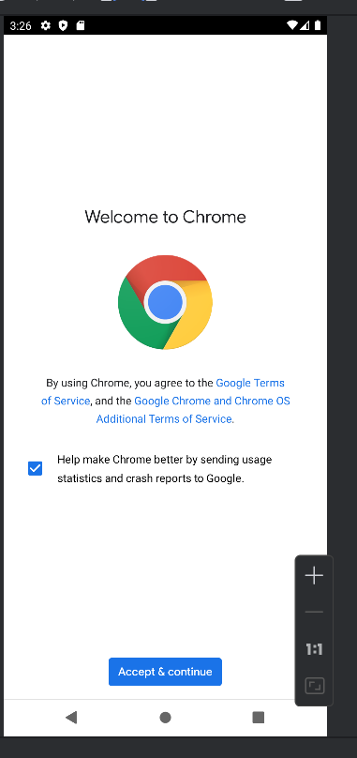**Output:**

**Task No 02:** Objective: To share content from one activity to another using an explicit intent. Description: Create an activity with a TextView displaying a piece of content (e.g., a quote or a fact). Implement a Button labeled "Share" that, when clicked, shares the content to another app (e.g., messaging or social media).

**Solution:**

package com.example.assignment1;  
  
import androidx.appcompat.app.AppCompatActivity;  
import android.content.Intent;  
import android.net.Uri;  
import android.os.Bundle;  
import android.view.View;  
import android.widget.Button;  
import android.widget.TextView;  
import android.view.View;  
public class MainActivity extends AppCompatActivity {  
 @Override  
 protected void onCreate(Bundle savedInstanceState) {  
 super.onCreate(savedInstanceState);  
 setContentView(R.layout.*activity_main*);  
 TextView contentTextView = findViewById(R.id.*contentTextView*);  
 Button shareButton=findViewById(R.id.*shareButton*);  
 shareButton.setOnClickListener(new View.OnClickListener() {  
 String content = contentTextView.getText().toString();  
 @Override  
 public void onClick(View v) {  
 Intent shareIntent = new Intent(Intent.*ACTION_SEND*);  
 shareIntent.setType("text/plain");  
 shareIntent.putExtra(Intent.*EXTRA_TEXT*, content);  
 startActivity(Intent.*createChooser*(shareIntent, "Share via"));}});}}

**Output:**